Wood Cutting Diagram
Draw in how you will cut out the pieces of wood that you need in order to make your golf hole. Be efficient and do not waste wood. Don’t forget to include any materials needed to build animals, obstacles, and info displays. Label each piece of wood with dimensions and a letter. Use capital letters for plywood pieces and lowercase letters for 2 x 4s.

2 x 4s  (actually 1.5” x 3.5” x 8’) | Plywood  (0.344” x 3.98’ x 7.98’)
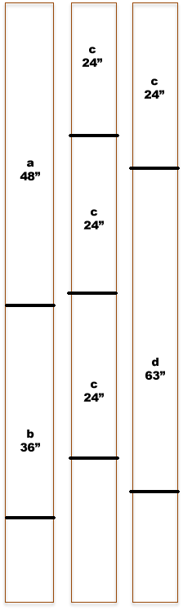 | 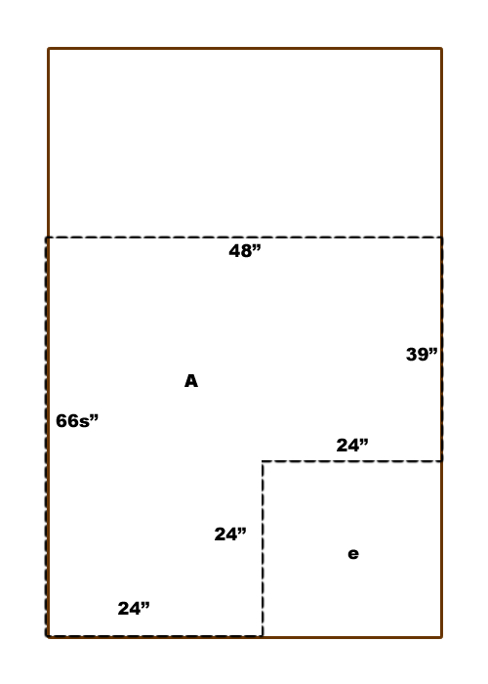
Total 2x4s needed: 3 | Total plywood boards needed: 1

Materials List
Based upon your wood cutting diagrams above, complete the materials list below.
Item | Price | Quantity | Cost
2 x 4s | $3.59 per board | 3 | $10.77
Plywood | $17.63 per board | 1 | $17.63
Artificial Turf | $0.44 / sq ft. | 17 sq ft | $7.48
 |  | Total | $35.88

