Step: Building Frame

Parts and Materials
- 3 2x4s
- Screws

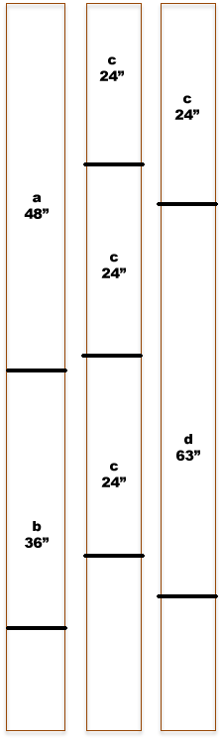
Tools
- Drill
- Saw
- Screwdriver

Step-by-Step Explanation
- Collect materials above
- Cut 2x4s according to cutting diagram
- Place 2x4s according to blueprints
- Predrill 2 screw holes at each 2x4 joint
- Use screwdriver to connect 2x4s at each joint

Diagrams and Drawings That Highlight the Steps

